Peer Observations Guide
“Michigan State University (MSU) Extension helps people improve their lives by bringing the vast knowledge resources of MSU directly to individuals, communities and businesses.”

Contents
Peer Observations Guide 1
Background and Purpose 1
Peer Observation Process 3
FORM A: Observation Form 4
FORM B: Optional Note-Taking Form 7
FORM C: Observation Completion and Reflection Form 8
Additional Resources 10

Background and Purpose
At its heart, MSU Extension focuses on translating and communicating research-based knowledge. To achieve our mission, we must know how to teach. Most MSU Extension employees teach, whether it be in fields, schools, or in the basement of a community center; one-on-one or to a group. MSU Extension values excellence in teaching. The goals of this peer observation process are to:
- create a culture that values best practices in teaching;
- provide learning opportunities for employees to reflect upon their own teaching and facilitative leadership skills and learn from their peers; and
- build capacity in teacher training, observation feedback, and general pedagogy within the organization.
Peer observations are about learning and reflecting, and should be descriptive, not evaluative. Their results are not an evaluative part of the performance management process. However, the completion of observations can be monitored through the collection of a copy of FORM C: Observation Completion and Reflection Form. What is learned from the experience can inform professional development plans regarding teaching skills if this is a chosen area of professional development.
Before the observation, the teacher being observed will choose a few areas in which he or she would like the observer to focus. During the observation, the observer will closely note the following: what is happening in the class, what the teacher is saying and doing, what materials are being used, and what the participants are saying and doing. Feedback should be descriptive, with the option of providing positive feedback. Negative evaluative feedback is discouraged, although descriptive notes can still reveal “problems” in the class. Examples to help illustrate descriptive and evaluative feedback are below:
Descriptive | Evaluative  (Avoid!) | Explanation
@9:45, you asked a question to the group and asked them to respond in chat. No one answered and many participants did not have video turned on. | Participants were disengaged. | The evaluative comment is negative, and does not give details of HOW students were disengaged.
Teacher used breakout rooms in Zoom and groups answered a few discussion questions. During debrief, after rejoining the room, many wanted to share responses. | Great interaction and engagement during group discussion questions. | The evaluative comment is positive, so although it is acceptable, it is more helpful to describe what happened- what was “great”?
PowerPoint presentation had 8 bullet points using a small font and many words. | PowerPoint had too many words and was hard to read. | The evaluative comment is negative, and does not describe the slides.
You used polls throughout the Zoom webinar successfully, launching a poll about every 10 minutes. You received many comments via the chat related to the topics in the poll. | The polls helped keep the participants engaged. | The evaluative comment is positive, so although it is acceptable, it is more helpful to describe what happened.
You asked participants to talk to a partner first about a stressful experience they had regarding unclear work expectations. When you asked for volunteers to share, five people responded. Later, you asked for volunteers to share a personal experience about x, y, z, without talking to a partner first. No one volunteered. | Good decision to ask participants to share their experiences with a partner before sharing with the entire class. | The evaluative comment is positive, so although it is acceptable, it is more helpful to describe what happened.

Peer Observation Process

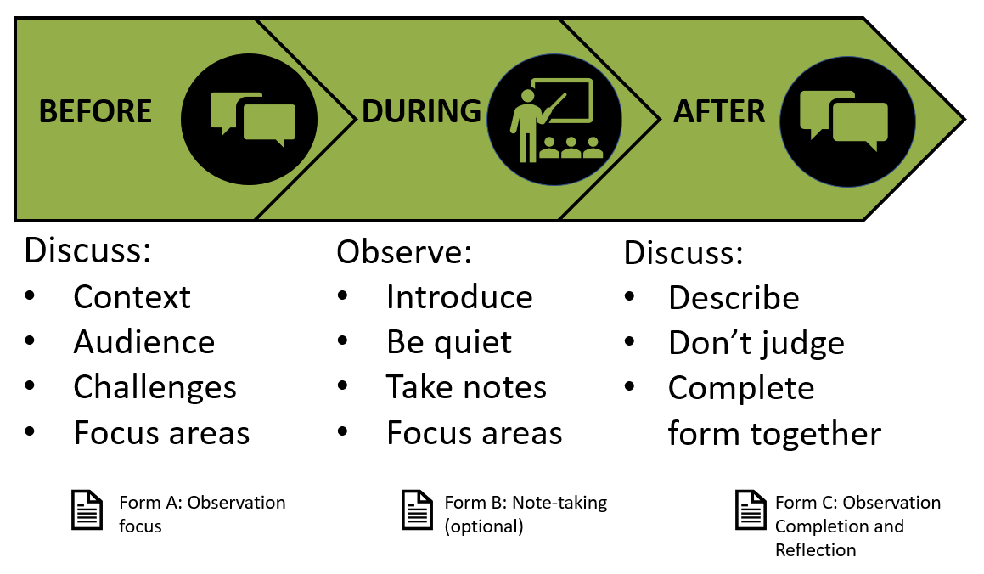
Before the Observation:
Either the teacher or the observer may initiate the observation. They will converse before the observation on the following topics:
Context and background for the class. Who are the learners? Is it part of a sequence? What are the objectives of the session being observed? What challenges has the teacher had? What online delivery method are you choosing, and why did you choose that? (ie, Zoom webinar or Zoom meeting)?
Desired areas of focus for the observation. Use FORM A: Observation Form to decide which categories to focus on. It is also acceptable to focus on other areas not included on this form.

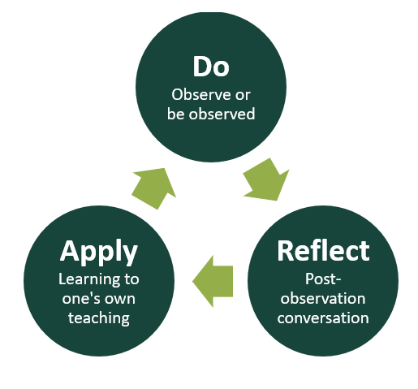
During the Observation:
The observer should arrive early and remain silent during the observation, refraining from commenting or participating. If appropriate, such as in smaller classes, the teacher should introduce the observer and explain that it is a friendly peer observation with the goal of learning from each other, and the focus is not the participants. The observer should take detailed notes on what is going on in the class, focusing on areas of interest indicated from the pre-observation discussion and chosen areas on FORM A: Observation Form.

After the Observation:
A follow-up conversation should occur between the observer and the teacher within a week of the observed class, using Form C: Observation Completion and Reflection Form to guide the conversation. The descriptive notes taken by the observer should also be used as a reference during this conversation. The observer should describe what they saw in class and may also make positive comments on any aspects of the teaching or the class that are noteworthy. The observer should refrain from making negative, evaluative comments.
If the teacher chooses to bring up an aspect of the class that he or she is not happy about, then he or she is free to open that up for discussion. However, the teacher, and not the observer, should bring these topics to the table. The conversation should focus on what happened during the session and what changes the teacher and observer think will result in a different outcome.

FORM A: Observation Form

Required: Use categories on this form to determine what to focus observation on.
Use this form before the observation to help pinpoint specific areas the teacher would like the observer to pay attention to. It is recommended to focus on 1-3 categories at a single observation. The observer can then use it during the observation to take notes, and again as a reference during post-observation discussions. Indicators should be used as only a guide; they are not all-inclusive, and some categories may not be appropriate for a given context.
Name of teacher: ______________________________________________
Name of observer: _____________________________________________
Date of class: _________________________________________________
Class topic: ___________________________________________________
Category | Indicators | Notes
Curriculum Choice and Development This category only applies when the teacher also developed the curricula. | - Program objectives and materials are appropriate for target audience  - Content and materials are research-based  - Content and materials reflect MSU Extension values of creating a welcoming and inclusive space  - Supporting materials are current and well-chosen
Preparedness | - Begins and ends on time  - Has significant disciplinary knowledge; is technically accurate  - Logical organization of instructional time and presentation (evidence of planning)  - Professional appearance of materials  - Power Points (if used) embrace instructional design theory
Teaching Skills - Class pace and sequence | - Pace is comfortable and appropriate for the learners  - Sequence of activities and topics is logical  - Transitions between topics are smooth  - Reviews previous materials and links them to new materials  - Presents information in appropriate chunks  - Moves from presenting new material to having learners apply or practice what they are learning
Knowledge and Application of Technology | - Uses available technologies in an appropriate way  - Supports the learners their use of the technology  - Implements contingency plans if technology fails
Teaching Skills - Interaction | - Provides opportunity for interaction  - Uses appropriate technologies for interaction (polls, chat, Q&A, breakout rooms, annotations, etc. are use appropriately)  - Uses a variety of question types and levels  - Skillfully facilitates discussion for entire group or sets up breakout rooms for successful discussion encouraging all to interact, mediating any contentious statements, correcting misconceptions, etc.
Teaching Skills - Learner Centeredness | - Demonstrates understanding of learner needs and priorities  - Activates background knowledge of learners and makes use of participants’ world experiences  - Helps students view relevancy of material in their own lives  - Recognizes and accommodates differences among learners  - Respects varied cultures and viewpoints  - Adjusts materials and lesson as needed to accommodate learning needs
Formative assessment and feedback  Not program evaluation. This refers to what the teacher does to gauge participant learning during the lesson. | - Uses formative assessment to check comprehension and adjust teaching  - Requires learners to demonstrate their learning  - Provides clear and appropriate corrective feedback
Classroom Control | - Uses routines and norms to dictate interactions in online environment  - Monitors and debriefs on any breakout room activity  - Clearly provides directions for activities or interactions  - Participants are on-task and paying attention
Presentational Skills | - Uses video (when internet connection allows) to create instructor presence  - Establishes rapport with participants  - Uses appropriate tone, volume, speed, inflection of voice  - Speaks naturally; not “reading” notes or slides out loud  - Uses appropriate language and word choice  - Uses non-verbal communication well: eye contact, gestures, movement  - Uses appropriate supporting visuals  - Includes examples and situations relevant to learners  - Demonstrates flexibility if issues related to teaching environment or technology occur

FORM B: Optional Note-Taking Form
Optional: Observers are not required to use this form; it is simply an option. Feel free to modify and do what works for you.
Teacher:_________________________ Date:________________ Class content: ______________________________________________
Areas of focus for observation: ____________________________________________________________________________________________
Start time | Activity: topic and materials | Teacher does/says | Students do/say

Check the interaction patterns you saw during the class.
- Teacher to class: Lecturing, explaining, demonstrating, giving directions; when the teacher is addressing the class.
- Teacher to student: Giving feedback to an individual student.
- Student to another student: Pair work; when a student is asking a question or conversing with another student.
- Student to class: When a student is addressing the entire class. This could be a participant giving a more formal explanation/presentation, answering a question, telling a story, or giving an example to the class.
- Group work: When students are broken into groups and groups are working together on an activity or discussing something within their group.

FORM C: Observation Completion and Reflection Form

Required: Use this form after observation, during the post-observation conversation. Complete it together during this conversation.

Teacher: | Observer:
Date of class: | Class topic:
Observation focus(es): (see form A categories)


Discussion on what happened in the class: The observer should share his or her description of what happened during the class. While positive feedback is appropriate, the observer should refrain from evaluative negative feedback.


Teacher reflection: What did you learn? What are you happy about with the lesson? What would you like to improve on?
Teacher next steps: Based on the above, what actions do you plan to take?

Observer reflection: What did you learn from watching the teacher? What topics related to teaching do you want to discuss of learn more about from this experience?

Observer next steps: Based on the above, what actions do you plan to take?

__________________________________ __________________________________
Signature of observer Signature of teacher

